**Docker Commands from Lab 1.1**

**Create file & build image from container on Ubuntu OS**

**Project Scenario:**

1. Check docker services
2. Create container & file
3. Build image from container
4. Build container form my image

**Practical Work:**

1. Check docker services  
   first check docker version  
   **$ docker version**

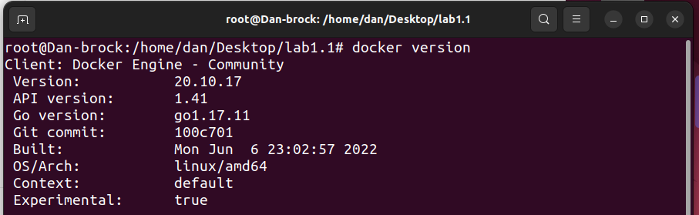  
now check docker status

**$ service docker status**

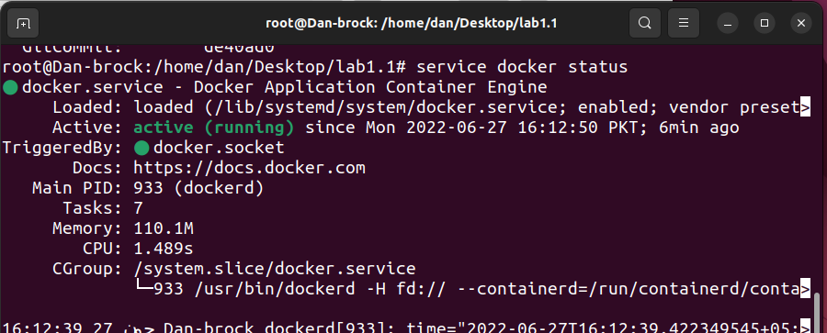

Let’s start docker service now **$ service docker start**

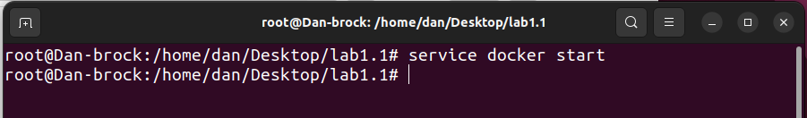

1. **Create container & file**create container from Ubuntu   
   **$ docker run –name test-v1 –it ubuntu**  
   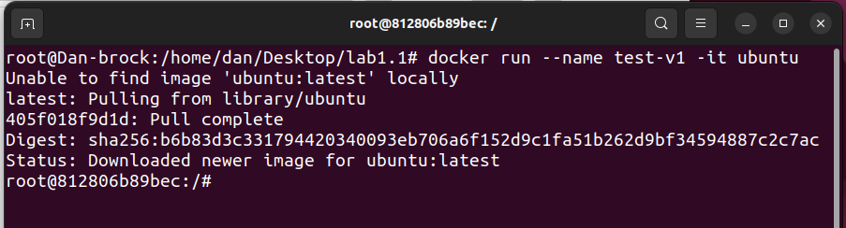  
   check the directories

**$ ls**

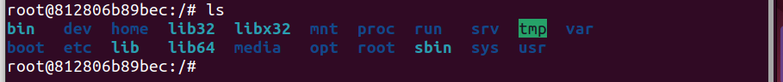enter on the tmp directory

**$ cd tmp**



& checkthe directories

**$ ls**

Make a directory in it with the name of testfile-1

**$ touch testfile-1**



& checkthe directories now

**$ ls**



Exit now

**$ exit**



Check diff

**$ docker diff test-v1  
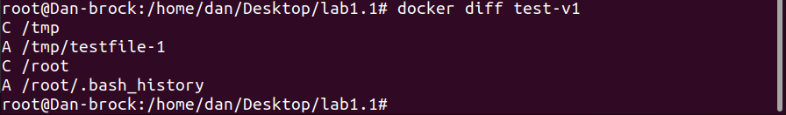**

1. **Build image from container**

Build a image from container

**$ docker commit test-v1 my-image**

& check image list

**$ docker images**

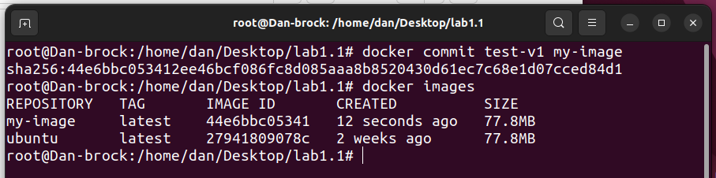

1. **Build container form my image**

Now I create a container form this image

**$ docker run –it –name your-image my-image /bin/bash**

& check container list

**$ ls**

& open tmp directory

**$ cd tmp**

& check directory list

**$ ls**

Exit now

**$ exit**

